SARGAM VERMA  Assistant Professor  Human Resource Management  MOBILE: 8279409769  EMAIL- sargamv42@gmail.com | 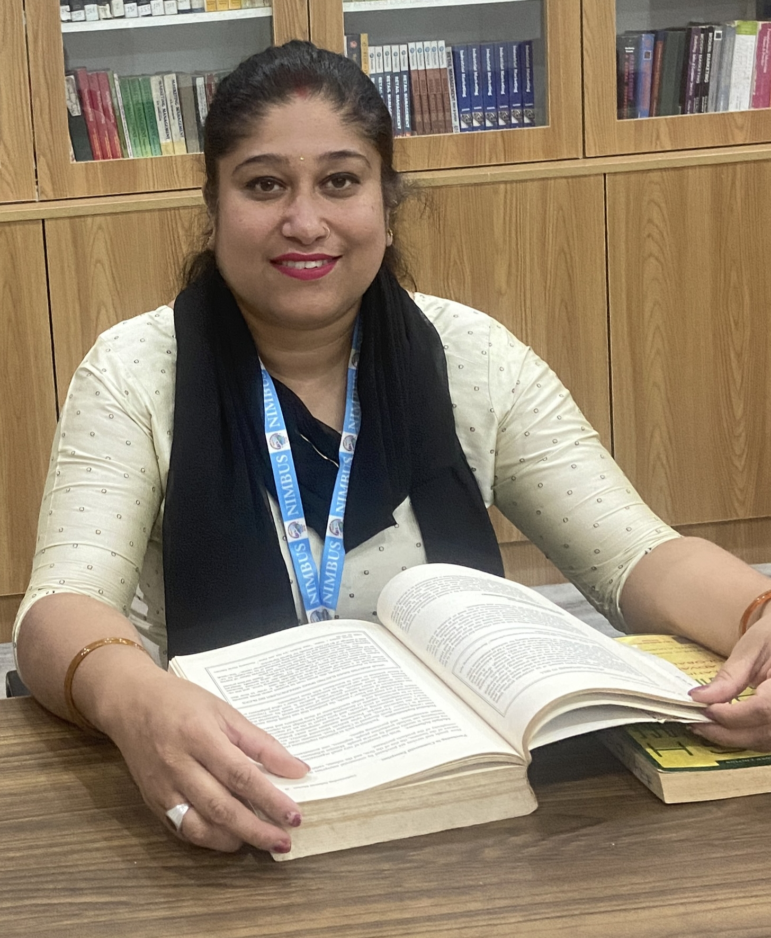

Short bio
Sargam verma is an Assistant professor in management at Nimbus Academy of Management. She did a master's in human resource management from Punjab technical University.She has 4 years of teaching experience. Her area of teaching/training includes different aspects of education such as communication softkills , management, motivation, influence, moral education, persuasion, and communication.

Academic Area and Degrees

- Academic Area: Human Resource Management.
- Degrees: Bcom., MBA(HR)

Work experience

- Assistant Professor at Nimbus Academy of Management.
- Senior soft skills and communication trainer at Jetking dehradun
- Given training to different clients including ONGC, collges
- Communication trainer at Doon Institute of English Language Dehradun
- Communication trainer at Hero Mind Mine(HEROGROUPS) Dehradun

Teaching

- Life skills and PD
- Business Communication
- Marketing Management
- Production and Operations mangment
- EBanking
- Content marketing
- Professional business Communication

Research Interests

- Communication
- Soft skills and PD
- HR managment

Details Of National Webinar

One day National Webinar on guidence for writing an effective research paper organised by internal quality Assurance Cell on 18 December 2023 at Nimbus Academy of Management.

Details of training
Attended 1 week training session from LQUID Noida

Attended 1 week training at JETKING Delhi.

Achievement And Awards

Certified trainer from Liquid Noida.

